**__________________________________________________________________________________**

**Emp Name**: **Radha Ankush Kadam**

**Emp Id: 46218925**

* **What is Jenkins?**

Jenkins is an open-source continuous integration/continuous delivery and deployment (CI/DI) automation software DevOps tool written in the java programming language. It is used to implements CI/CD workflows, called pipelines

It helps automate the parts of software development related to building, testing, and deploying, facilitating continuous integration and continuous delivery.

* **Why Jenkins??**

Jenkins is used to build and test your product continuously, so developers can continuously integrate changes into the build.

Jenkins is the most popular open-source CI/CD tool on the market today and is used in support of DevOps, and other cloud native tools.

* **Features of Jenkins:**

**Easy Installation**

Jenkins is a platform-agnostic, self-contained Java-based program, ready to run with packages for Windows, Mac OS, and Unix-like operating systems.

* **Easy Configuration**

Jenkins is easily set up and configured using its web interface, featuring error checks and a built-in help function.

* **Available Plugins**

There are hundreds of plugins available in the Update Center, integrating with every tool in the CI and CD toolchain.

* **Extensible**

Jenkins can be extended by means of its plugin architecture, providing nearly endless possibilities for what it can do.

* **Easy Distribution**

Jenkins can easily distribute work across multiple machines for faster builds, tests, and deployments across multiple platforms.

* **Free Open Source**

Jenkins is an open-source resource backed by heavy community support.

As a part of our learning about what is Jenkins, let us next learn about the Jenkins architecture

**6 Steps to Install Jenkins on Windows**

1. Install Java Development Kit (JDK) ...
2. Set the Path for the Environmental Variable for JDK. ...
3. Download and Install Jenkins. ...
4. Run Jenkins on Localhost 8080. ...
5. Jenkins Server Interface. ...
6. Build and Run a Job on Jenkins.

* **Architecture of Jenkins:**

Windows Slave Node

Jenkins Master(UI)

Apple OSX Slave Node

**TCP Connection**

Linux Slave Node

* Developers commit changes to the source code, found in the repository.
* The Jenkins CI server checks the repository at regular intervals and pulls any

newly available code.

* The Build Server builds the code into an executable file. In case the build fails,

feedback is sent to the developers.

* Jenkins deploys the build application to the test server. if the test fails,the developers are alerted.
* If the code is error free, the tested application is deployed on the production

server

* **Installation Steps:**

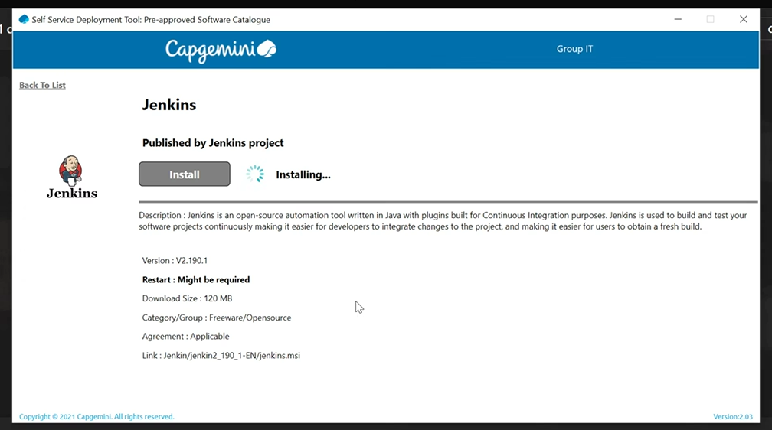

### Step 1: Download Jenkins

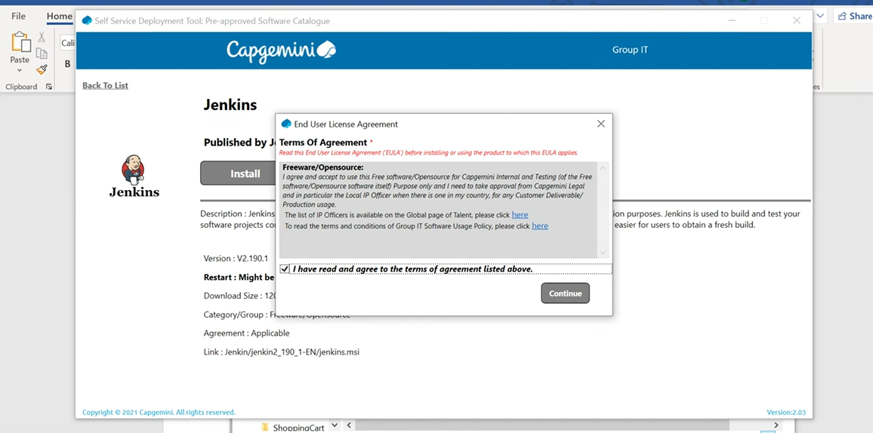

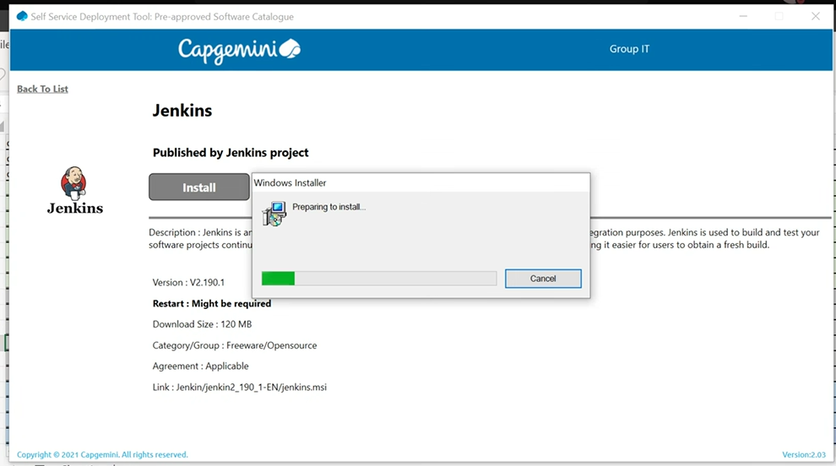

Run the installer

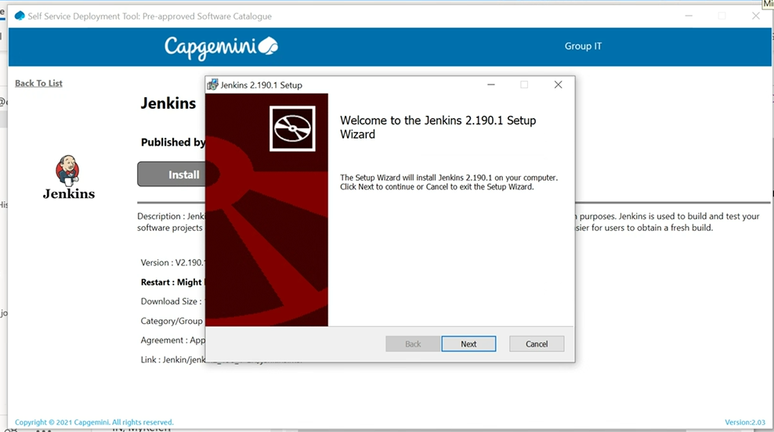

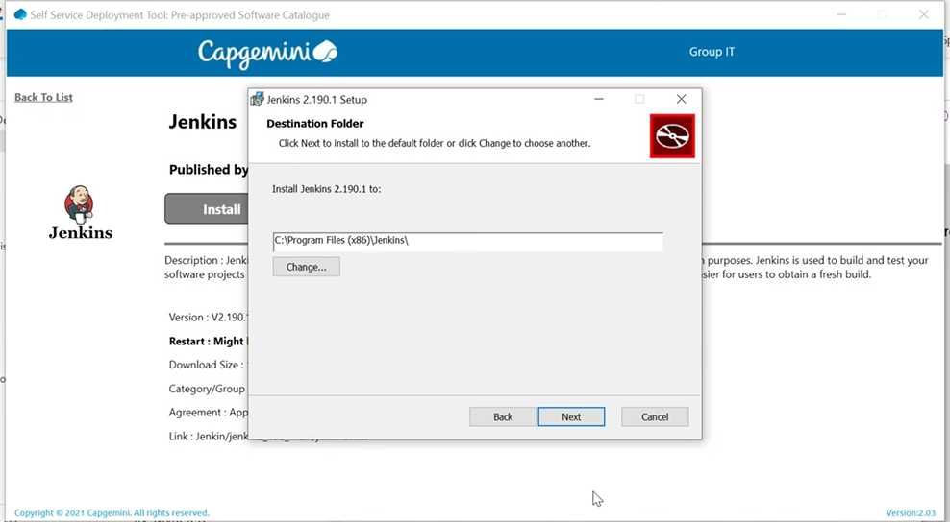

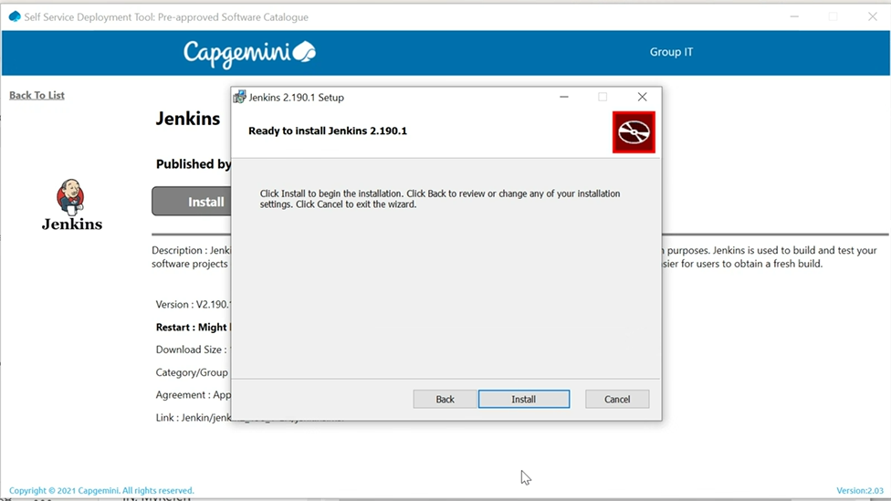

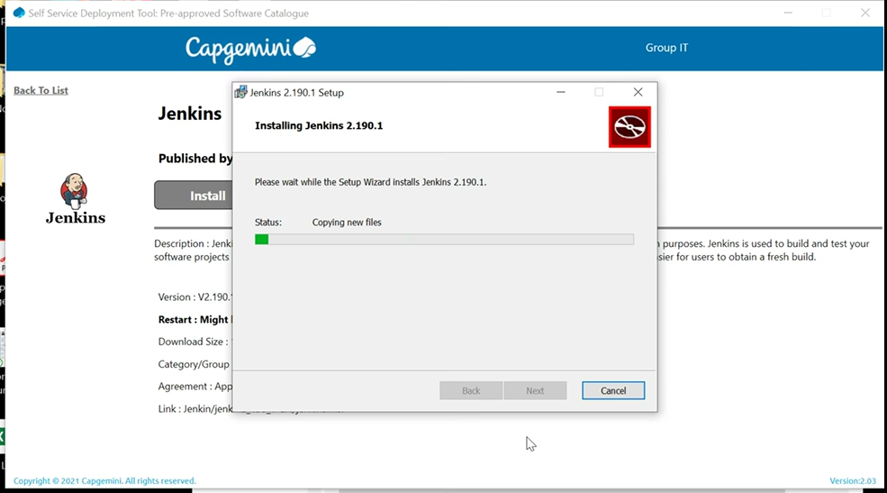

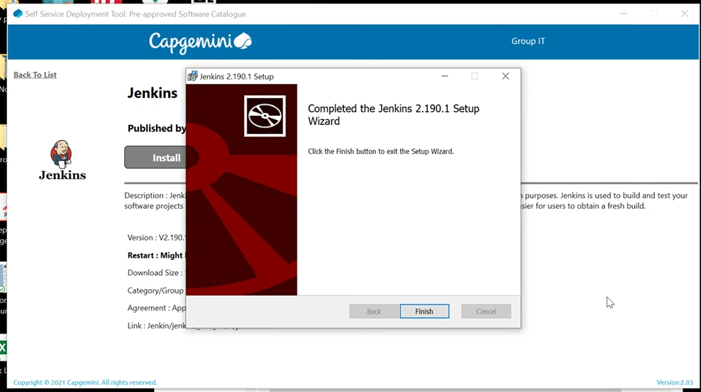

### Get the installation password

As soon as the installation is complete, it will open a new browser page pointing to this URL: http://localhost:8080/

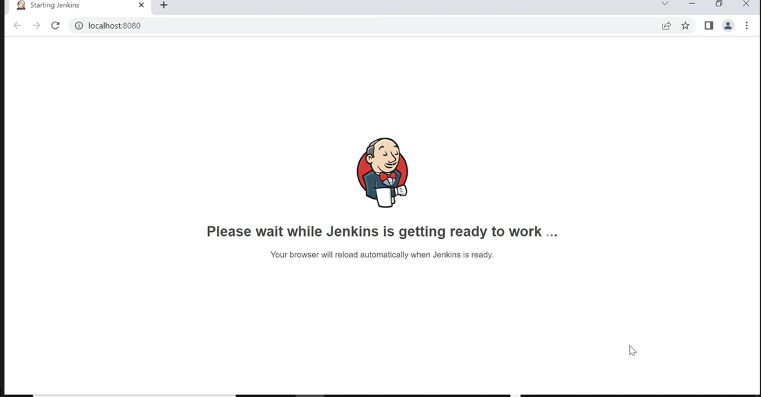

Next, we need to open the file mentioned (initialAdminPassword) with Notepad or any other text editor and copy the password.

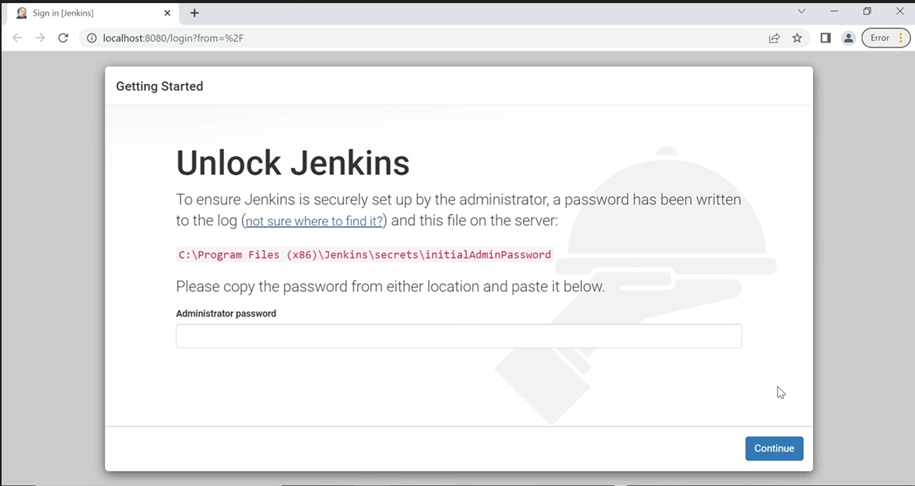

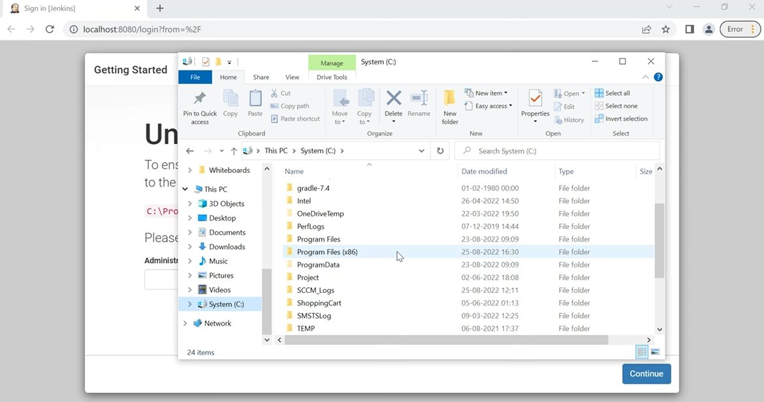

**Open the below folder (as per your system folder structure) and secret key file**

C:\Program Files (x86)\Jenkins\secrets

File name : initialAdminPassword

Copy the secret key from here and paste it in the bowser Administrator password textbox (0b082742481b4467b6bbc178dceb2351) and continue

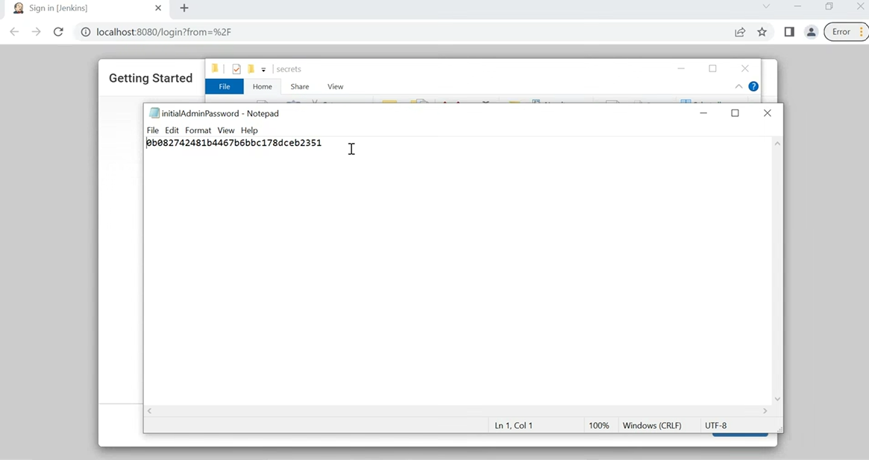

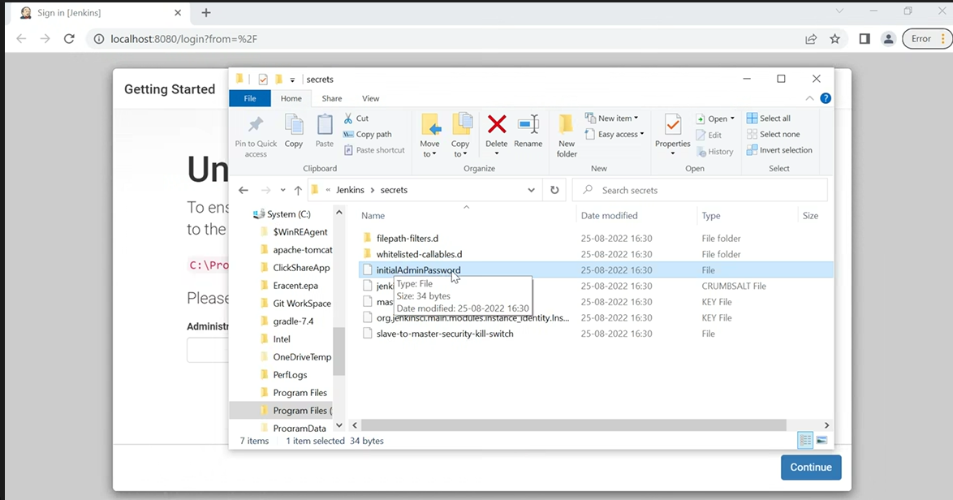

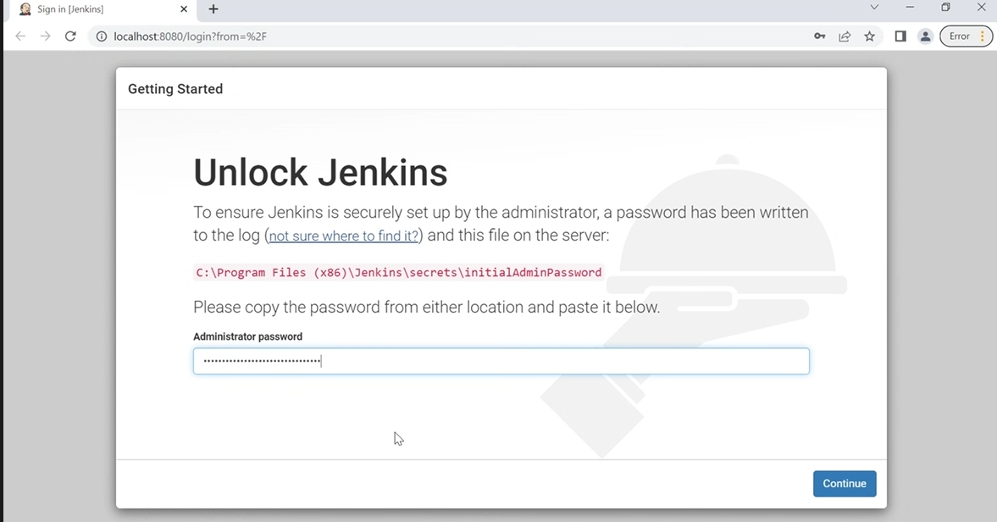

**Let’s Configure Jenkins now**

Once you have installed Jenkins in any of the ways presented, it is time to do the final setup.

### Step 4: Install plugins

Jenkins is composed of multiple components called plugins. The next step asks which plugins we would like to install. Just install the suggested plugins.

**Install suggested plugins**

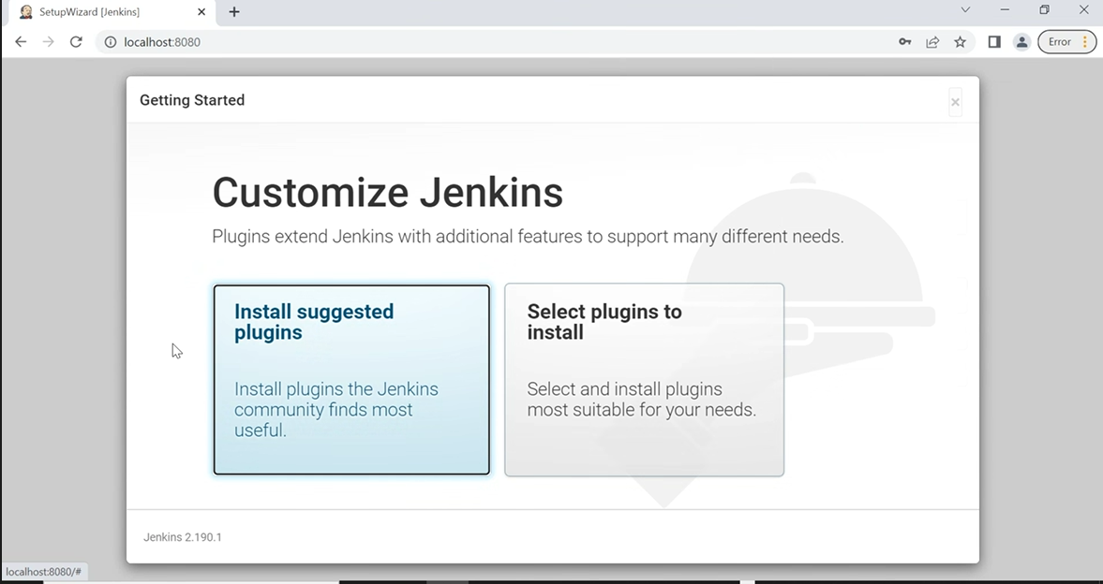

**Select Install suggested plugins**

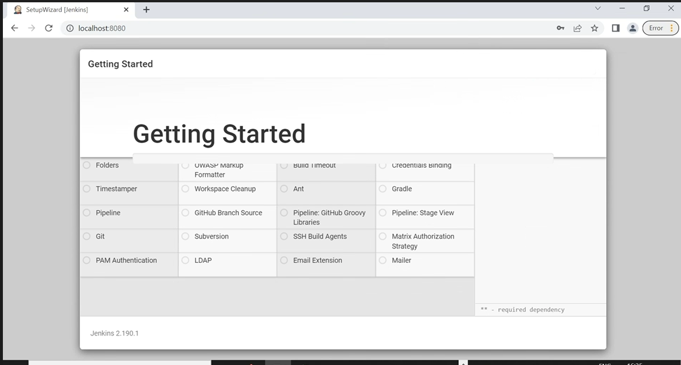

Once we have installed Jenkins in any of the ways presented, it is time to do the final setup.

### Configure the Jenkins URL

The final step is to configure the URL for the Jenkins server. This would be prefilled for you. So, all we need to do is to click “**Save and finish**“.

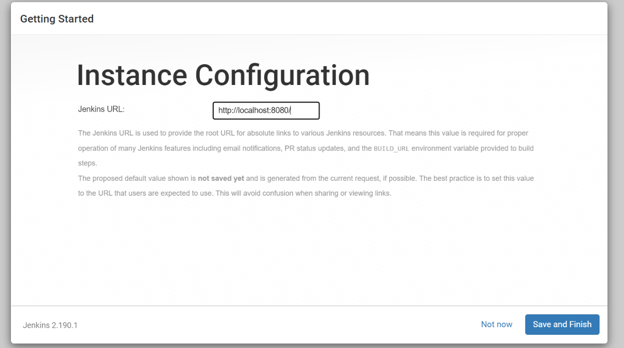

### Now you are all set to use Jenkins

### 

**Create new Project**

### Now we are all set to use Jenkins

